Agent manual

Guide for using the Emma Web Portal

Table of Contents

Emma Agent Login 2

User Query 2

Unanswered Queries 5

Query History 5

User Profile 5

# Emma Agent Login

Once your System Administrator has created an account for you in the Emma database, using your email address and password, log into the Emma Web Portal here:

<http://54.206.55.193/emma/index.php>

You will know that you have successfully logged in when you see your name in the top left hand corner of the Emma Web Portal main page. In the right main panel, you will see a message asking you to select a user from the left queue. If there are no users visible in the left queue, you do not need to proceed any further.

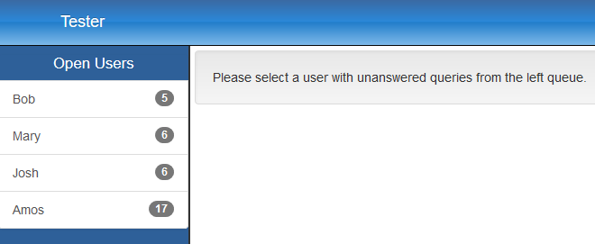

If there are any users in the left queue under an “Assigned Users” heading, click the user at the top of this queue as the users here have previously been assigned to you. If there are no “Assigned Users”, click the user at the top of the “Open Users” queue. In both cases, the user that appears at the top of the queue has the oldest open query and should be given priority.

# User Query

Once you have selected a user, it will move from the “Open Users” queue to your “Assigned Users” queue. If you are presented with a message stating that the user has already been assigned to another agent, try a different Open User.

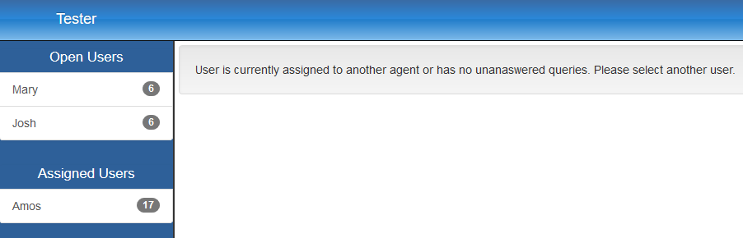

The “User Query” tab in the right main panel will show the selected user’s oldest unanswered query. If the text content of this query does not appear to make sense because of a poor audio to text conversion, you can re-listen to the audio query using the audio controls on this page, edit the text content and click on the “Fix this query” button. If an image file accompanied this query, it will also appear on this page. Clicking on the image will open a full-sized version of it in a new tab.

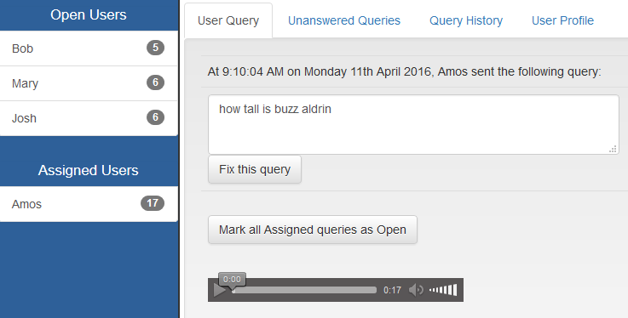

Below the query content, the result of passing the user’s query into Google Search and the user’s location at the time of the query in Google Maps will be displayed. You can scroll through the top 10 results from Google or click on the “Google’s Results” heading to open Google in a new tab. You can use the Google Maps controls, drag across the map or click on the “Location” heading to open Google Maps in a new tab for additional functionality such as directions.

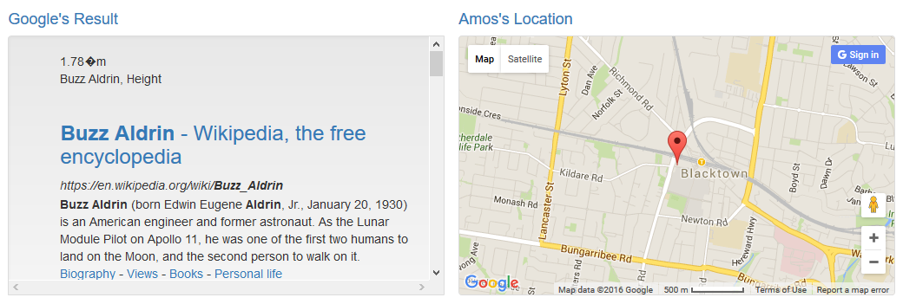

Once you have found the required information to answer the user’s query, you can type in a text response to this single query and click on the “Submit this answer” button. Please provide context in your response as each answer addresses a single query but the user is likely to have several unanswered queries.

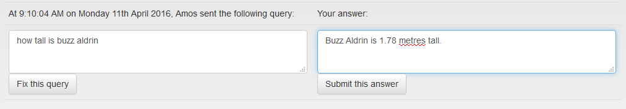

For example, a query asking “How tall is Michael Jordan?” should be answered with a response stating “Michael Jordan is 1.98 metres tall” rather than “1.98m”.

If you are unable to answer all of the user’s queries that have been assigned to you, for example, if you need to step away from your desk or if the user’s query requires the expertise of another agent, please click on the “Mark all Assigned queries as Open” to release the user from your “Assigned Users” queue and back into the “Open Users” queue. This is automatically done for all users assigned to you when you log out of the system.

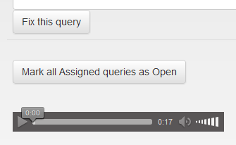

# Unanswered Queries

This tab shows up to 10 unanswered queries for the selected user.

# Query History

This tab shows the last 20 queries for the selected user regardless of whether they have answered or remain unanswered. They are ordered from oldest to newest.

# User Profile